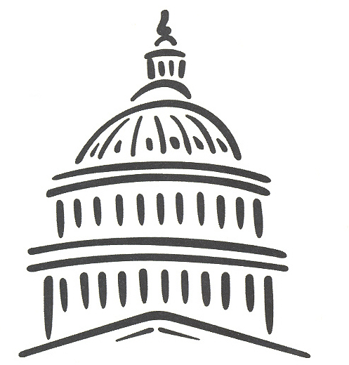

2023
“Government-In-Action” Youth Tour
Essay Contest Application Deadline - 5:00 P.M. January 31, 2023
Name:

Address:

City: State: Zip:

Phone: Birth Date:

School and Grade:

School Counselor Signature (to verify status of student)

Parent/Guardian Name:_

Parent/Guardian Signature:

Account Number with Bartlett Electric Cooperative, Inc.:

Name on Account:

Relationship to Student:

Return to Bartlett Electric Cooperative, Inc., 27492 Highway 95, Bartlett, Texas 76511, Attn: Carrie Wenzel.

2023 Youth Tour

Bartlett Electric Cooperative, Inc. will sponsor one area student for an all-expense paid trip to Washington, D.C. The winner will join over 100 others from Texas on this exciting trip. On Rural Youth Day, the Texas group will meet participants from other states at the Nation’s capital where they will meet their State Representatives. Nearly 1,500 students will gather to learn about each other and what life is like in other parts of the U.S.A.

Contest Rules

- Applicants must be high school juniors or seniors.

- Applicant’s parents/guardians must be members of Bartlett Electric Cooperative, Inc. or an employee of the Bartlett Electric Cooperative, Inc.

- Applicant must reside in the home of parents/guardians who are employees or full-time residents of a home serviced by Bartlett Electric Cooperative, Inc.

- Applicants must submit one completed application along with an essay of not more than 500 words in length, 12-point type and double spaced on the following topic:

In what ways have you noticed electric cooperatives in Texas making a difference for those in their communities? What opportunities do you see for Cooperatives and Cooperative Members to continue to make a difference for their neighbors? Why do you think this is important?

- The essays must be typed - no handwritten entries will be accepted.

- The essays may be delivered to the Bartlett Electric office at 27492 Hwy 95, Bartlett, TX or mailed to:

Bartlett Electric Cooperative, Inc. Youth Tour Contest
27492 Highway 95
Bartlett, Texas 76511 Attn: Carrie Wenzel

- Essays must be received in the office no later than 5:00 p.m. on January 31, 2023.

The Selection Process

- A panel of judges will select from the written essays submitted.

- If you are chosen but find that you are unable to participate in the trip, please contact Bartlett Electric Cooperative, Inc. as soon as possible.

- The dates for next year’s tour are June 11-19, 2023.

- A runner-up will represent Bartlett Electric Cooperative, Inc. on the trip in case the winner is not able to attend.

